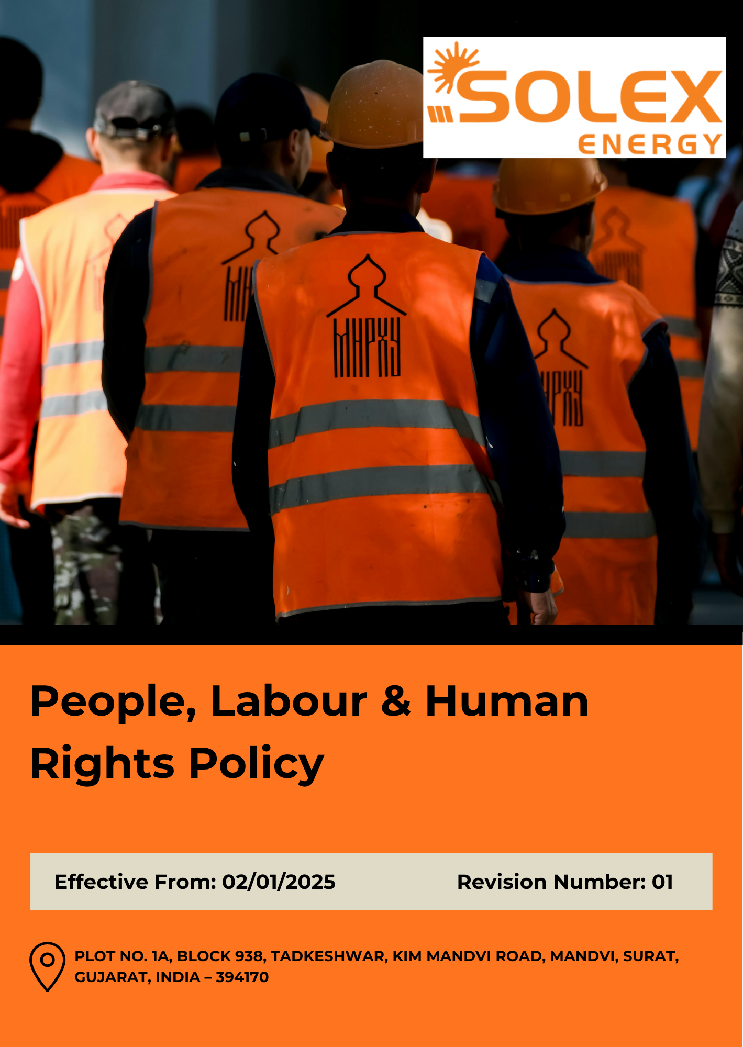

INDEX

1. Purpose & Policy Statement 3
2. Scope 3
3. Labour & Human Rights Priority Areas 3
4. Our Strategic Goals and Commitments 6
5. Our Measurable Targets 9
6. Contribution to the Sustainable Development Goals (SDGs) 12
7. Governance 13
8. Reporting Channels & Non-Retaliation 15
9. Performance Reporting 16
10. Review Mechanism 17
11. Employee Acknowledgement 18

1. Purpose & Policy Statement
Solex Energy Limited is committed to respecting, protecting, and promoting labour and human rights across its operations and business relationships. The Company strives to provide a safe, healthy, inclusive, and respectful workplace that promotes fair working conditions, equal opportunity, employee development, open communication, and employee engagement.
Solex Energy Limited does not tolerate child labour, forced labour, human trafficking, discrimination, harassment, violence, abuse, exploitation, or any other violation of human rights. The Company is committed to complying with applicable labour and human rights laws and expects all employees, contractors, suppliers, and business partners to uphold these principles. Through responsible employment practices, training, grievance mechanisms, and continual improvement, the Company aims to protect employee dignity and foster a fair, safe, and productive workplace for all.

2. Scope
This Policy applies to all employees, contractual workers, trainees, contractors, and other persons working on behalf of Solex Energy Limited. Where relevant, it also extends to suppliers, service providers, and business partners.
The Policy covers labour and human rights matters across the Company's operations, including occupational health and safety, fair working conditions, employee engagement and social dialogue, career development and training, prevention of child and forced labour, human trafficking, discrimination, harassment, and other forms of exploitation or abuse.
Solex Energy Limited | Block No. 938, Plot No. 1A, Tadkeshwar, Taluka Mandvi, Kim–Mandvi Road, District Surat, Gujarat – 394170, India

3. Labour & Human Rights Priority Areas
Solex Energy Limited is committed to maintaining a workplace that respects human rights, promotes employee well-being, provides fair and dignified working conditions, and supports equal opportunities for all employees and workers. The following key labour and human rights aspects are considered relevant to the Company.
- Respect for Human Rights & Human Dignity: Solex Energy Limited prioritizes respect for fundamental human rights and the dignity of every individual associated with its operations. The Company aims to maintain a workplace free from abuse, intimidation, degrading treatment, and practices that may adversely affect individual rights. Human rights considerations are integrated into relevant employment and workplace practices, with expectations extended to contractors and business partners where appropriate.

- Safe & Healthy Workplace: Solex Energy Limited prioritizes the protection of employee health, safety, and wellbeing through systematic identification and management of workplace hazards. Key areas include safe operation of machinery and equipment, electrical safety, chemical handling, material movement, fire and emergency preparedness, personal protective equipment, workplace inspections, incident reporting, and safety awareness. The Company seeks to strengthen preventive measures and reduce workplace incidents through training and continual improvement.
- Fair Employment, Workplace Practices & Employee Voice: Solex Energy Limited prioritizes fair and responsible employment practices covering wages, working hours, leave, benefits, workplace facilities, and other employment conditions. The Company encourages open communication between employees and management and provides appropriate opportunities for employees to provide feedback and raise workplace concerns. Respect for applicable freedom of association and collective representation rights is also promoted.
- Discipline, Dismissal & Termination: Solex Energy Limited prioritizes fair, consistent, and transparent approaches to disciplinary action, dismissal, resignation, and termination. Disciplinary measures are intended to be proportionate to the nature of the issue and implemented without physical punishment, threats, humiliation, or other degrading treatment. Employment separation is managed in accordance with applicable legal and contractual requirements, including appropriate communication and settlement processes.
- Learning, Professional Growth & Employee Wellbeing: Solex Energy Limited prioritizes continuous learning, technical and functional skill development, career progression, and employee wellbeing. Training needs are identified based on job responsibilities, performance, operational requirements, and emerging business needs. The Company aims to provide employees with opportunities to enhance their capabilities through induction, technical training, health and safety training, professional development, and performance feedback.
- Equality, Inclusion & Respectful Conduct: Solex Energy Limited prioritizes equal opportunity, diversity, inclusion, and respectful workplace behaviour. Employment decisions relating to recruitment, development, promotion, compensation, and career opportunities are intended to be based on relevant qualifications, skills, experience, performance, and business requirements. Discrimination, harassment, bullying, intimidation, and sexual harassment are not tolerated, and employees are encouraged to report concerns through established channels.
- Responsible Recruitment & Protection of Vulnerable Workers: Solex Energy Limited prioritizes responsible and transparent recruitment practices. Employment conditions should be clearly communicated to workers, and appropriate documentation and age-verification processes are maintained. Particular attention is given to protecting contract, temporary, migrant, young, and other vulnerable workers from unfair treatment, exploitation, unsafe conditions, or practices that may restrict their rights.
- Prevention of Child Labour, Forced Labour & Human Trafficking: Solex Energy Limited prioritizes the prevention of child labour, forced or compulsory labour, bonded labour, human trafficking, slavery, and other forms of labour exploitation. The Company maintains appropriate recruitment and age-verification controls and expects workers to enter employment voluntarily. Relevant contractors, labour agencies, suppliers, and business partners are also expected to uphold these principles within their respective operations and employment practices.
- Grievance & Speak-Up Mechanisms: Solex Energy Limited prioritizes accessible and effective mechanisms through which employees and workers can raise grievances, workplace concerns, ethical issues, and human rights-related matters. Grievances are expected to be handled fairly, confidentially, and within appropriate timelines. The Company promotes a non-retaliatory environment so that individuals can raise concerns in good faith without fear of adverse consequences.

4. Our Strategic Goals and Commitments
Solex Energy Limited has established key goals and commitments to strengthen workplace practices, enhance employee well-being, promote fair and inclusive employment, protect fundamental rights, and support continuous improvement across its operations.

4.1 Respect for Human Rights & Human Dignity
Solex Energy Limited commits to:
- Respect internationally recognized human rights in accordance with the Universal Declaration of Human Rights, UN Guiding Principles on Business and Human Rights, and Constitution of India (Articles 14–23).
- Prohibit forced, bonded, child labour, human trafficking, modern slavery, harassment, abuse, and discrimination.
- Identify and address material human-rights risks across operations and relevant business relationships.
- Respect freedom of association and collective bargaining in accordance with the Trade Unions Act, 1926 and Industrial Disputes Act, 1947.
- Maintain confidential, accessible, and retaliation-free mechanisms for reporting human-rights concerns.
4.2 Safe & Healthy Workplace
Solex Energy Limited shall:
- Provide and maintain a safe and healthy workplace that prevents work-related injuries and occupational illnesses.
- Identify and control risks related to manufacturing, electrical systems, machinery, chemicals, material handling, maintenance, warehousing, and logistics.
- Apply the hierarchy of controls and provide appropriate PPE, training, and supervision.
- Maintain effective controls for emergency preparedness, fire, electrical, machinery, chemical, and other material safety risks.
- Monitor occupational health and provide appropriate medical checks for employees exposed to hazardous processes.

4.3 Fair Employment, Workplace Practices & Employee Voice
Solex Energy Limited shall:
- Provide clear employment terms and comply with applicable requirements relating to wages, working hours, overtime, leave, and statutory benefits.
- Ensure timely payment of wages, appropriate payslips, and lawful wage deductions.
- Prohibit unlawful withholding of wages and other unfair employment practices.
- Respect freedom of association and collective bargaining where legally applicable.
- Provide employees with appropriate channels for communication, participation, feedback, and raising concerns without retaliation.
4.4 Discipline, Dismissal & Termination
Solex Energy Limited shall:
- Prohibit arbitrary dismissal, corporal punishment, coercion, intimidation, and degrading treatment.
- Provide employees a fair opportunity to respond before disciplinary action is taken.
- Apply the principles of natural justice in disciplinary matters.
- Maintain appropriate documentation and consistent disciplinary procedures.
- Ensure disciplinary action and termination comply with the Industrial Employment (Standing Orders) Act, 1946 and applicable legal requirements.
4.5 Learning, Professional Growth & Employee Wellbeing
Solex Energy Limited shall:
- Provide appropriate induction, technical, functional, behavioural, and compliance-related training.
- Support employee learning, skill development, professional growth, and career progression.
- Conduct appropriate performance and development discussions for eligible employees.
- Promote physical, psychological, and social wellbeing and address excessive stress, fatigue, and burnout.
- Promote employee engagement, work-life balance, and responsible workload management.

4.6 Equality, Inclusion & Respectful Conduct
Solex Energy Limited shall:
- Provide equal opportunity in recruitment, employment, compensation, training, development, and career progression.
- Prohibit discrimination, harassment, bullying, intimidation, and abuse based on protected characteristics.
- Maintain zero tolerance for sexual harassment in accordance with the POSH Act, 2013, through the Site's Internal Complaints Committee (ICC).
- Promote diversity, inclusion, and equal opportunities for women and underrepresented groups.
- Maintain appropriate mechanisms for reporting and addressing discrimination and harassment concerns.
4.7 Responsible Recruitment & Protection of Vulnerable Workers
Solex Energy Limited is committed to recruitment practices that protect workers from exploitation, coercion and unfair treatment.
The Company shall:
- Maintain fair, transparent, and legally compliant recruitment and onboarding practices.
- Verify the age, identity, and employment eligibility of employees and workers.
- Prohibit child labour, forced labour, bonded labour, human trafficking, unlawful document retention, and unlawful recruitment fees.
- Provide additional safeguards for vulnerable workers against exploitation, discrimination, and abuse.
- Require relevant contractors, recruitment agencies, and labour-service providers to comply with applicable human-rights and labour requirements.
4.8 Grievance & Speak-Up Mechanisms
Solex Energy Limited shall:
- Provide accessible channels for raising concerns relating to workplace conditions, human rights, discrimination, harassment, health and safety, and unethical conduct.
- Allow concerns to be raised through supervisors, Department Heads, Human Resources, EHS/Safety representatives, and established grievance or whistleblower mechanisms.
- Maintain confidentiality and appropriately record, investigate, and address reported concerns.
- Prohibit retaliation, intimidation, or adverse treatment against individuals raising concerns in good faith.
- Escalate serious or systemic concerns to appropriate management or governance levels.
4.9 Prevention of Child Labour, Forced Labour & Human Trafficking
Solex Energy Limited shall:
- Prohibit human trafficking and all forms of exploitation, including recruitment, transportation, or employment through force, coercion, deception, or abuse of vulnerability.
- Prohibit child labour and ensure compliance with applicable minimum-age requirements.
- Verify and document the age and identity of employees and workers during recruitment.
- Prohibit forced, bonded, or involuntary labour, debt bondage, coercion, unlawful recruitment fees, and inappropriate document withholding.
- Extend child labour, forced labour, and human trafficking requirements to relevant contractors, suppliers, subcontractors, and manpower agencies.
- Investigate suspected violations and take appropriate corrective action, including safe removal and rehabilitation support where child labour is identified.

5. Our Measurable Targets
5.1 Respect for Human Rights & Human Dignity
- Maintain zero (0) confirmed cases of human rights violations, discrimination, harassment, or forced labour through Year 2030.
- Conduct human rights risk assessments covering 100% of identified high-risk operational activities and relevant high-risk supply chain areas by Year 2030.
- Provide human rights awareness and responsible workplace training to 100% of employees and relevant contractors annually through Year 2030.
- Acknowledge human rights-related grievances within 48 hours and resolve 100% of substantiated grievances within 30 days, where practicable, through Year 2030.
- Maintain 100% compliance with applicable human rights and labour laws and regulations through Year 2030.
5.2 Safe & Healthy Workplace
- Maintain a zero-fatality objective for work-related incidents through Year 2030.
- Conduct occupational health and safety risk assessments covering 100% of operational facilities and major work activities annually through Year 2030.
- Provide appropriate occupational health and safety training to 100% of employees and relevant contractors annually through Year 2030.
- Achieve ISO 45001 certification coverage of 100% of the Company's operational site by 2030.
- Maintain 100% compliance with applicable occupational health and safety laws and regulations through Year 2030.

  - Fair Employment, Workplace Practices & Employee Voice
- Ensure 100% of employees receive wages within the prescribed payroll timeline, with payment by the 5th of each month where this is the company's established payroll commitment, through Year 2030.
- Maintain 100% compliance with applicable minimum wage, working-hour, overtime, and wage-payment requirements through Year 2030.
- Maintain zero (0) confirmed cases of unlawful wage deductions or non-payment of wages through Year 2030.
- Acknowledge employee concerns promptly and resolve 100% of substantiated concerns within 30 days, where practicable, through Year 2030.
- Achieve an employee satisfaction score of at least 4.5 out of 5 on fairness, transparency, and workplace communication by Year 2030.

  - Discipline, Dismissal & Termination
- Maintain zero (0) confirmed cases of unfair, arbitrary, or unlawful dismissal through Year 2030.
- Complete disciplinary investigations within 15 days, where practicable, and conclude disciplinary actions within 30 days through Year 2030.
- Train 100% of relevant managers on fair disciplinary practices, due process, and natural justice principles annually through Year 2030.
- Maintain 100% compliance with applicable employment, disciplinary, and termination requirements through Year 2030.
- Maintain zero (0) confirmed cases of corporal punishment, intimidation, or other degrading treatment through Year 2030.

  - Learning, Professional Growth & Employee Wellbeing
- Provide mandatory training to 100% of employees annually through Year 2030.
- Increase average employee training hours by at least 25% from the 2023 baseline by Year 2030.
- Conduct employee wellbeing or engagement assessments covering 100% of employees annually through Year 2030.
- Reduce employee turnover by 25% from the 2023 baseline by Year 2030.
- Achieve an employee engagement score of at least 4.5 out of 5 by Year 2030.

  - Equality, Inclusion & Respectful Conduct
- Investigate 100% of formally reported discrimination or harassment concerns within 30 days, where practicable, through Year 2030.
- Maintain zero (0) confirmed cases of discrimination, harassment, bullying, or abuse through Year 2030.
- Increase diversity representation across relevant workforce categories and management levels to at least 20% by Year 2030, based on the 2023 baseline.
- Maintain no unexplained gender pay gap for employees performing comparable work of equal value through Year 2030.
- Provide POSH and prevention-of-sexual-harassment awareness training to 100% of employees annually, with additional periodic awareness sessions as required, through Year 2030.

  - Responsible Recruitment & Protection of Vulnerable Workers
- Conduct age and employment eligibility verification for 100% of newly recruited employees and workers through appropriate documentation and recruitment controls through Year 2030.
- Maintain zero (0) confirmed cases of illegal recruitment, forced labour, or unlawful document withholding through Year 2030.
- Ensure 100% of applicable recruitment agencies and labour contractors are appropriately licensed/registered and comply with applicable labour requirements through Year 2030.
- Ensure 100% of employee-held original documents are returned promptly upon request, with no unlawful retention, through Year 2030.
- Maintain 100% compliance with applicable recruitment and employment laws and regulations through Year 2030.
  - Grievance & Speak-Up Mechanisms
- Ensure 100% of material grievances and concerns are acknowledged within 48 hours through Year 2030.
- Investigate and appropriately address 100% of material concerns through established procedures within 30 days, where practicable, through Year 2030.
- Maintain zero (0) confirmed cases of retaliation against employees or other individuals who raise concerns in good faith through Year 2030.
- Achieve an employee confidence score of at least 4.5 out of 5 regarding grievance and speak-up mechanism effectiveness by Year 2030.
- Ensure 100% of employees receive awareness/training on grievance and speak-up mechanisms annually through Year 2030.
  - Prevention of Child Labour, Forced Labour & Human Trafficking
- Ensure 100% of employees and relevant contract workers receive awareness on child labour, forced labour, human trafficking, and reporting mechanisms by 2030.
- Maintain zero (0) confirmed cases of child labour, forced labour, bonded labour, or human trafficking through 2030.
- Ensure 100% of relevant suppliers, contractors, and subcontractors acknowledge applicable requirements under the Company's People, Labour & Human Rights Policy by 2030.
- Verify and document age and employment eligibility for 100% of new employees and workers through 2030.
- Maintain 100% compliance with applicable laws and regulations relating to child labour, forced labour, bonded labour, and human trafficking through 2030.

6. Contribution to the Sustainable Development Goals (SDGs)
Through the implementation of this Policy, Solex Energy Limited contributes to the achievement of the United Nations Sustainable Development Goals (SDGs), particularly SDG 3 (Good Health and Well-Being), SDG 4 (Quality Education), SDG 5 (Gender Equality), SDG 8 (Decent Work and Economic Growth), SDG 10 (Reduced Inequalities), and SDG 16 (Peace, Justice and Strong Institutions).
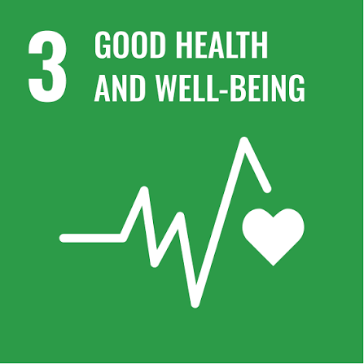 | 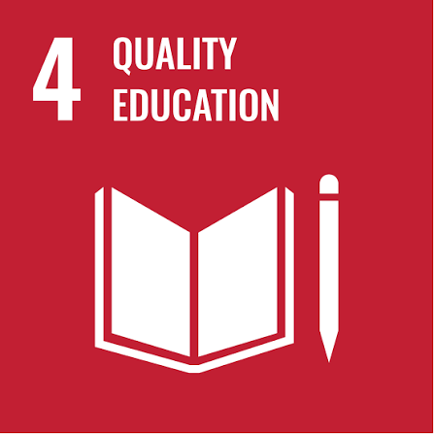 | 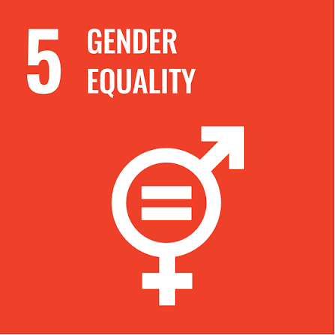 | 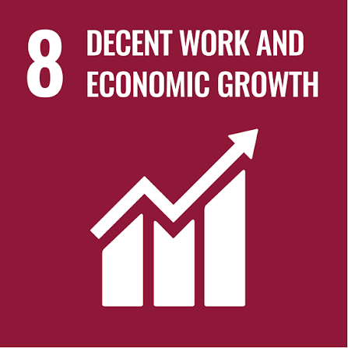 | 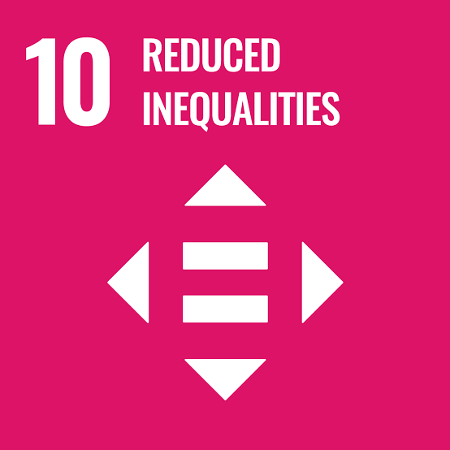


7. Governance
Board of Directors
Provides overall oversight of resources, people, workplace and human-rights risks and reviews the Company's performance through the established governance and risk-management framework.
Senior Management
Provides leadership, resources and accountability for implementation of this Policy and ensures that people, workplace and human-rights considerations are integrated into business decision-making.
Human Resources Manager
Acts as the primary custodian of this Policy and coordinates activities relating to employment practices, employee welfare, employee relations, learning and development, diversity and inclusion, grievance management, responsible recruitment, and labour and human rights compliance. Reviews and updates this Policy annually & whenever there are changes in applicable laws, regulations, Company procedures, workforce practices, or other relevant requirements.
EHS / Safety Officer
Leads occupational health and safety implementation, including risk assessment, safety training, incident management, inspections, emergency preparedness and safety performance monitoring.
Site / Facility Management
Ensures implementation of workplace, safety and employee-related requirements at facility level, provides appropriate resources and supports employee participation and corrective actions.
Department Heads & Supervisors
Ensure that employees receive appropriate information, training and support and that workplace requirements are implemented within their areas of responsibility.
Employees & Workers
Comply with applicable Company policies and procedures, participate in required training, report concerns and contribute to maintaining a safe, respectful and inclusive workplace.
Contractors
Are expected to comply with applicable contractual requirements and relevant labour, human-rights, health and safety expectations established by Solex.
Training effectiveness shall be periodically evaluated using assessments, feedback, observations, incident trends and other appropriate methods.

8. Reporting Channels & Non-Retaliation
Any employee, contractor, worker, supplier or other relevant stakeholder who becomes aware of a potential violation of this Policy may raise a concern through available Company reporting mechanisms, including:
- Direct reporting to the immediate supervisor or Department Head.
- Reporting to the Human Resources Manager.
- Reporting to the designated EHS / Safety representative for health and safety matters.
- Use of the Company's established grievance or whistleblower mechanisms.
- Escalation to senior management or the appropriate governance body for serious, unresolved or systemic concerns.
Solex strictly prohibits retaliation, intimidation, discrimination or adverse treatment against any person who raises a concern or reports a suspected violation in good faith.
Reported concerns shall be handled appropriately and confidentially, subject to applicable legal and procedural requirements.

9. Performance Reporting
Transparent and regular reporting is essential for monitoring the effectiveness of this Policy, ensuring accountability, and supporting continual improvement. Solex Energy Limited shall implement the following reporting practices:
- People, Labour & Human Rights Performance Reporting: Solex Energy Limited shall periodically review and report its performance against the commitments, objectives, targets, and key performance indicators established under this Policy. Reporting may include matters relating to human rights, health and safety, employee wellbeing, training, diversity and inclusion, grievances, recruitment practices, child labour and forced labour prevention, and compliance with applicable requirements.
- Internal Reviews and Assessments: Solex Energy Limited shall conduct periodic reviews, assessments, and audits, as applicable, to evaluate compliance with this Policy and related procedures. Findings shall be documented and appropriate corrective and preventive actions shall be implemented where necessary.
- Incident, Grievance and Concern Reporting: Solex Energy Limited shall maintain appropriate records of reported grievances, human rights concerns, workplace incidents, employee complaints, discrimination or harassment concerns, and other relevant matters. Significant or material issues shall be escalated to the appropriate level of management for review and action.
- Management Reporting: Performance results, significant incidents, grievance trends, corrective actions, compliance issues, and emerging risks shall be periodically reported to Senior Management and relevant governance bodies, as applicable. Management shall review such information to assess the effectiveness of controls and identify opportunities for improvement.
- Stakeholder Feedback: Solex Energy Limited shall consider relevant feedback received from employees, workers, contractors, suppliers, customers, communities, and other stakeholders. Where appropriate, such feedback shall be used to strengthen workplace practices, human rights management, employee wellbeing initiatives, and Policy implementation.
- Public Disclosure: Solex Energy Limited may disclose relevant information regarding its people, labour and human rights performance through sustainability reports, ESG disclosures, annual reports, the Company website, or other approved communication channels, in accordance with applicable disclosure requirements and while protecting confidential and personal information.

10. Review Mechanism
Human Resources Manager shall review this People, Labour & Human Rights Policy annually to ensure its continued relevance, effectiveness, and alignment with applicable legal, regulatory, operational, and stakeholder requirements.
The review shall consider performance against established targets, grievance trends, human rights and labour-related concerns, employee feedback, audit findings, workplace incidents, compliance obligations, and other relevant information.
The Policy shall be updated, where necessary, to reflect changes in applicable laws, regulations, Company procedures, business operations, workforce requirements, or identified risks and improvement opportunities. Significant updates shall be communicated to relevant employees and stakeholders.
Revision History
Revision No. | Date | Description of Change
0.0 | 02/01/2025 | Initial release of the People, Labour & Human Rights Policy.
1.0 | 02/01/2026 | Review and update of Policy commitments, measurable targets, performance reporting, and review mechanism.

Approved by:

[Name]
Chairman & Managing Director
Solex Energy Limited

11. Employee Acknowledgement
I acknowledge that I have received, read, and understood the People, Labour & Human Rights Policy of Solex Energy Limited. I understand that this Policy establishes the Company's commitments and expectations relating to human rights, labour practices, workplace conduct, health and safety, diversity and inclusion, employee wellbeing, responsible recruitment, grievance mechanisms, and the prevention of child labour and forced labour.
I understand that compliance with this Policy is mandatory and that I am responsible for performing my duties in accordance with its requirements and for reporting any suspected violations, concerns, or non-compliance through the designated reporting channels.
I understand that violations of this Policy may result in appropriate corrective or disciplinary action in accordance with Company procedures and applicable laws. I also acknowledge that this Policy is reviewed periodically and may be updated when required.
By signing below, I confirm my understanding of and commitment to comply with the People, Labour & Human Rights Policy.
Employee Name | __________________________________
Employee ID / Department | __________________________________
Acknowledgement Date | __________________________________
Employee Signature | __________________________________

